**Assignment-1: Connect and Disconnect with Login Access**

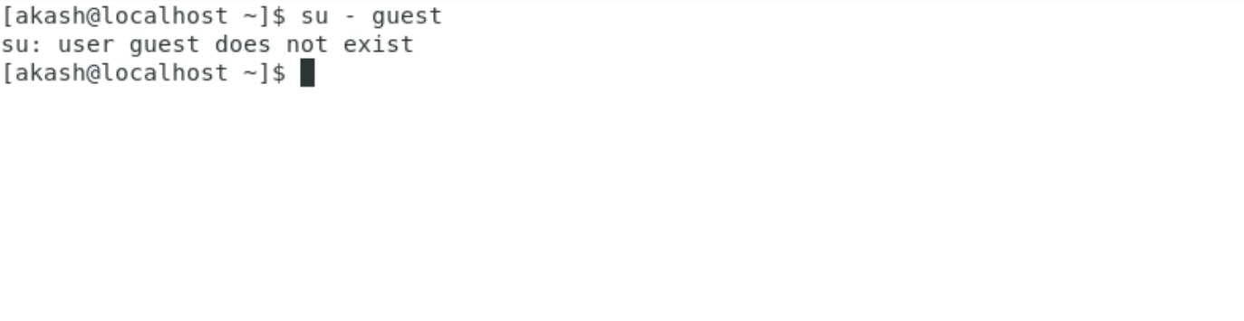

**Ans:**

When I try to login a non-existent users or username. It shows me a message that the user does not exist.

**Assignment-2: Password Changing**

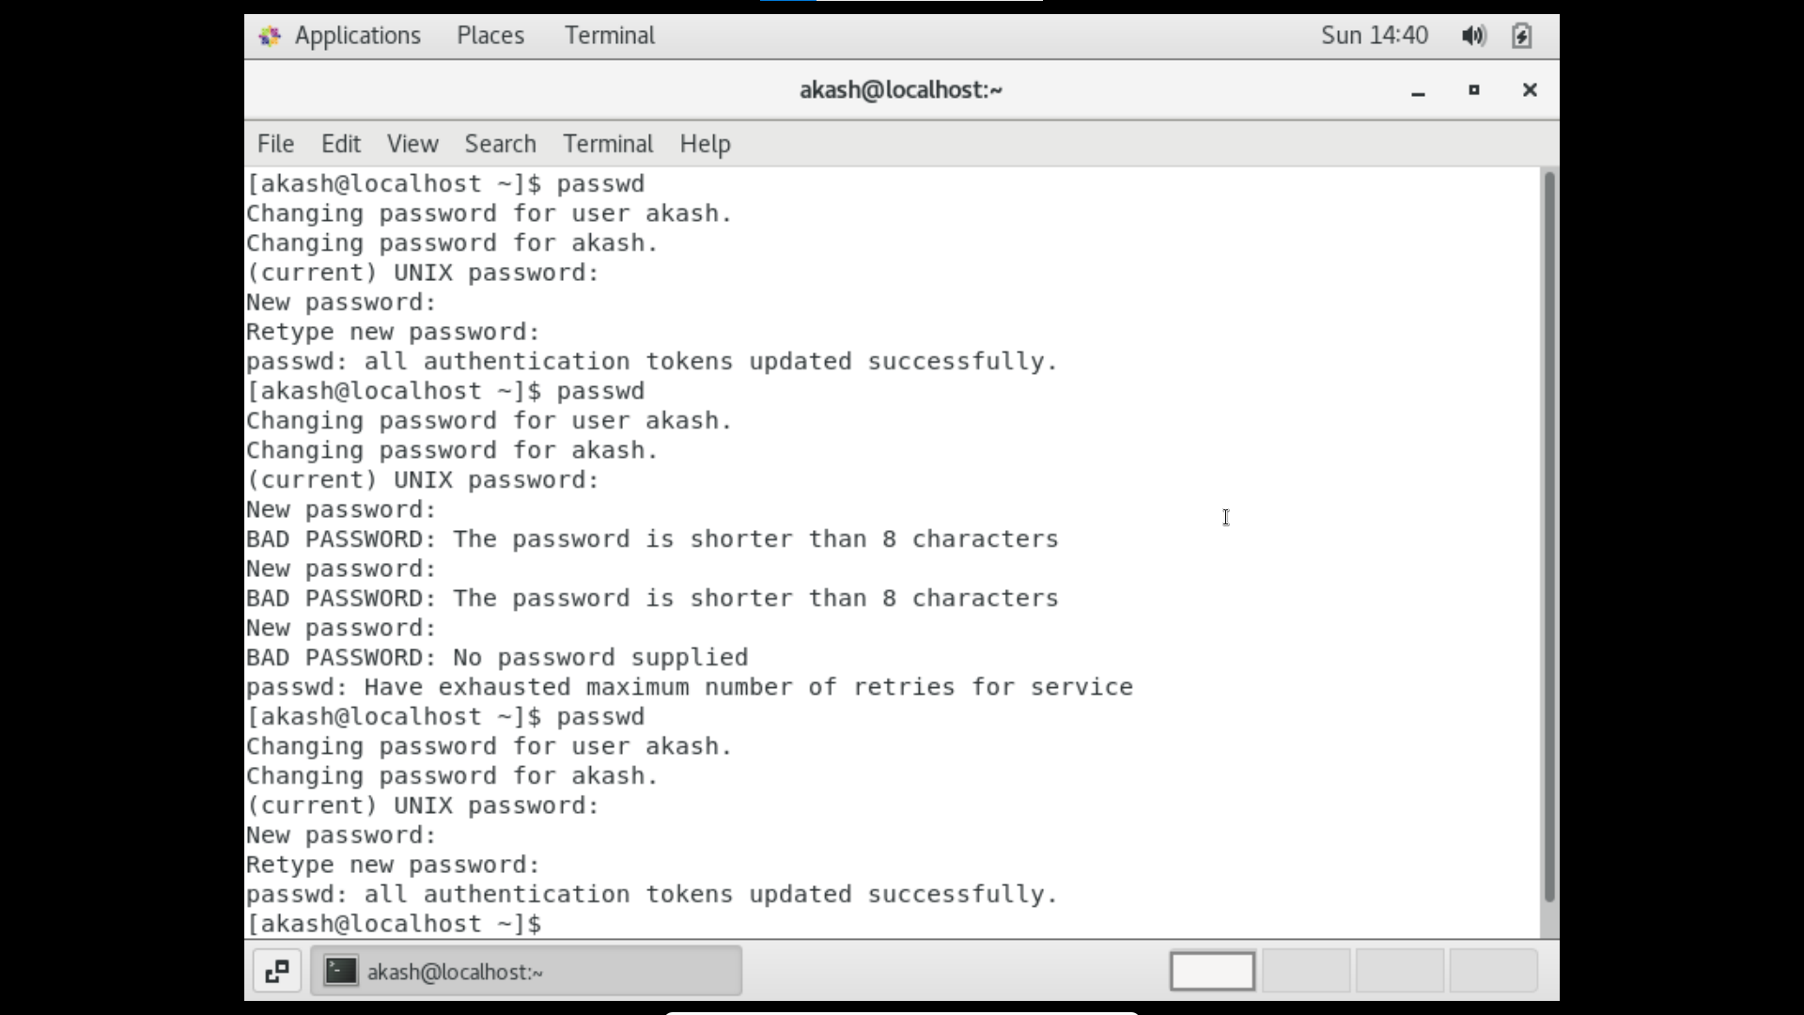

* Changed my password to **IneuR0n#42.** It got accepted.
* Changed my password to 1234 and tried with abcd as well. It shows a message that the password is shorter than 8 characters. Indicating that the password should aleast contain 8 characters.
* I tried to change my password with nothing, a simple enter. It shows me a message that BAD PASSWORD: No password is supplied. We must provide a password.

**Assignment-3: Working with Directories**

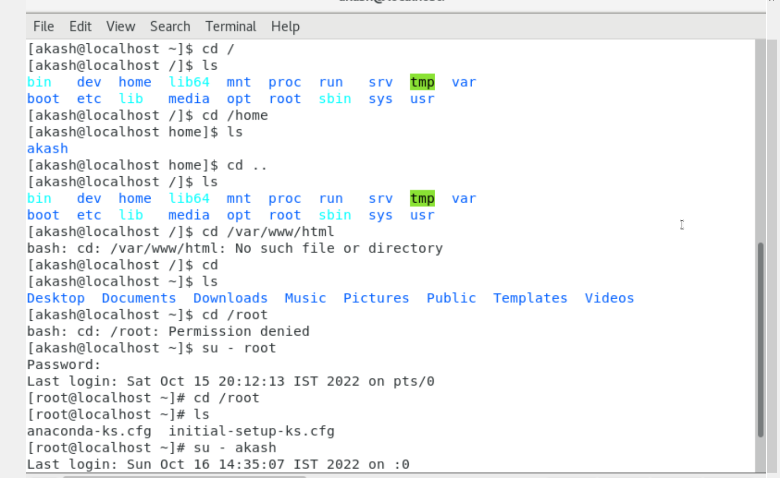

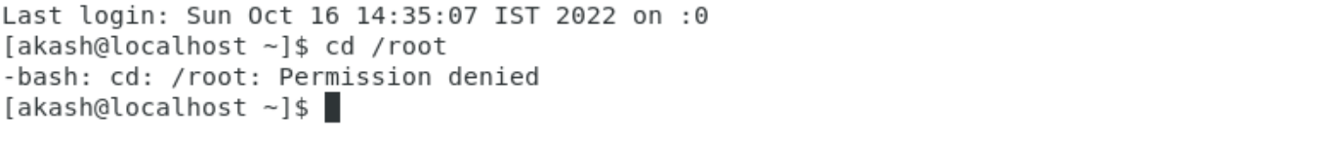

**Ans:**

* cd / command is to navigate to the root directory.
* cd /home command is to navigate to the home directory where the user’s directories are present.
* cd .. command is to take you to one step back of the present directory.
* /var/www/html is created when you install Apache HTTP server. cd /var/www/html command is to navigate to the folder. Since I did not install apache server, for me it is showing no directory is found.
* cd /root command is to navigate to the root user’s directory. For that we have to login as root user.

**Assignment-4: Working with File Listing**

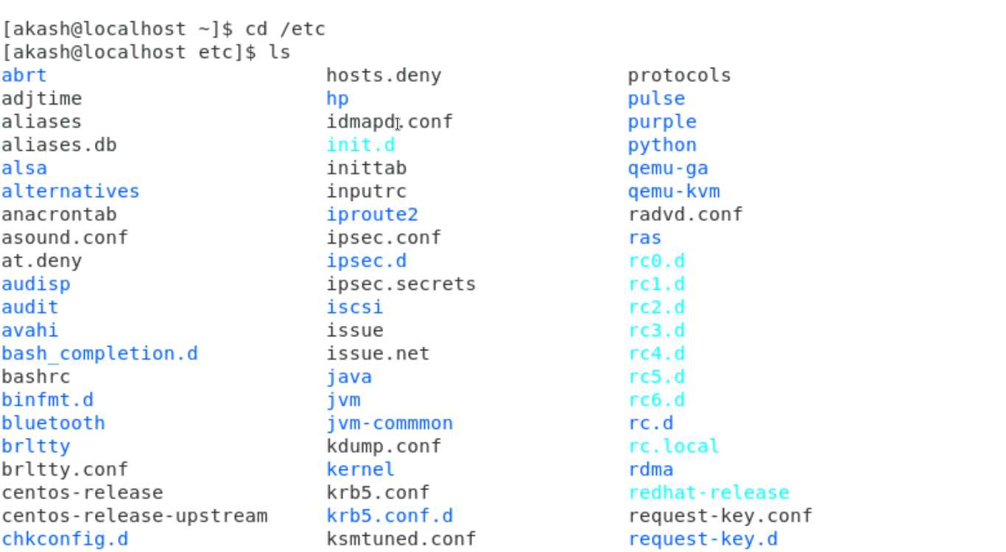

**Ans:**

/etc folder contains system’s configuration files. There are more than 200 files.

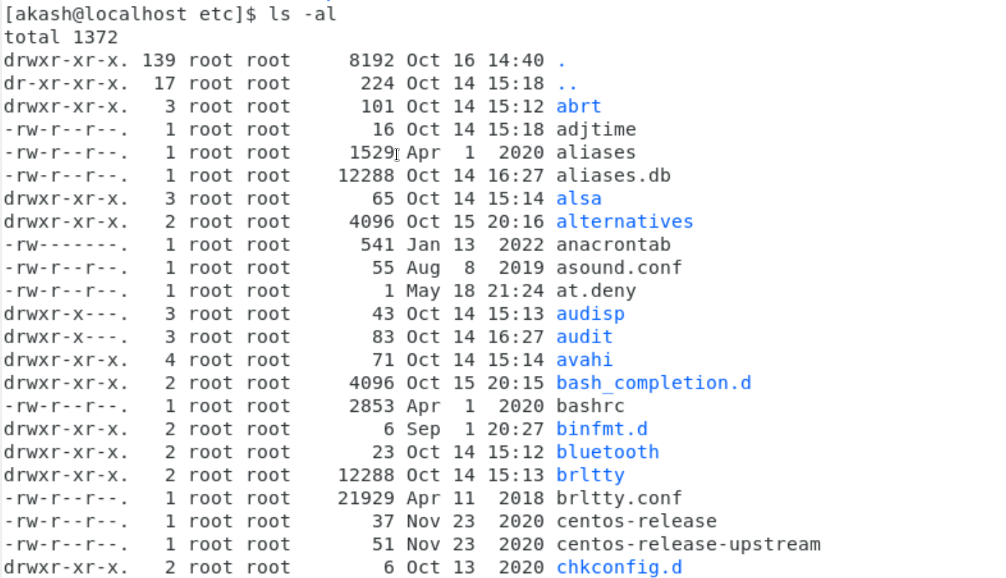

**Ans:**

Lists all the files including hidden files as well with their permissions over the user, group and others ( accessibility).

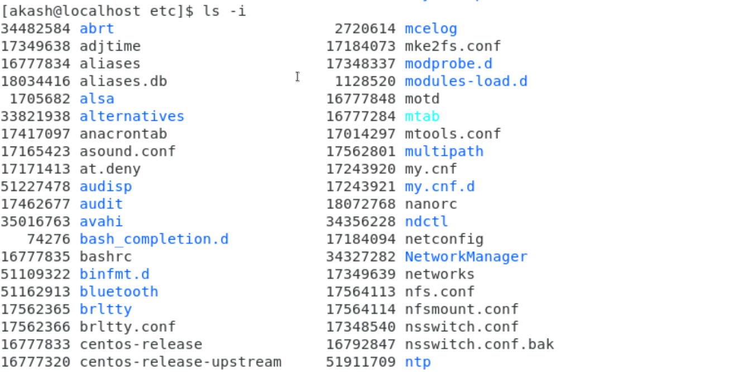

**Ans:**

Lists the files along with their index numbers.

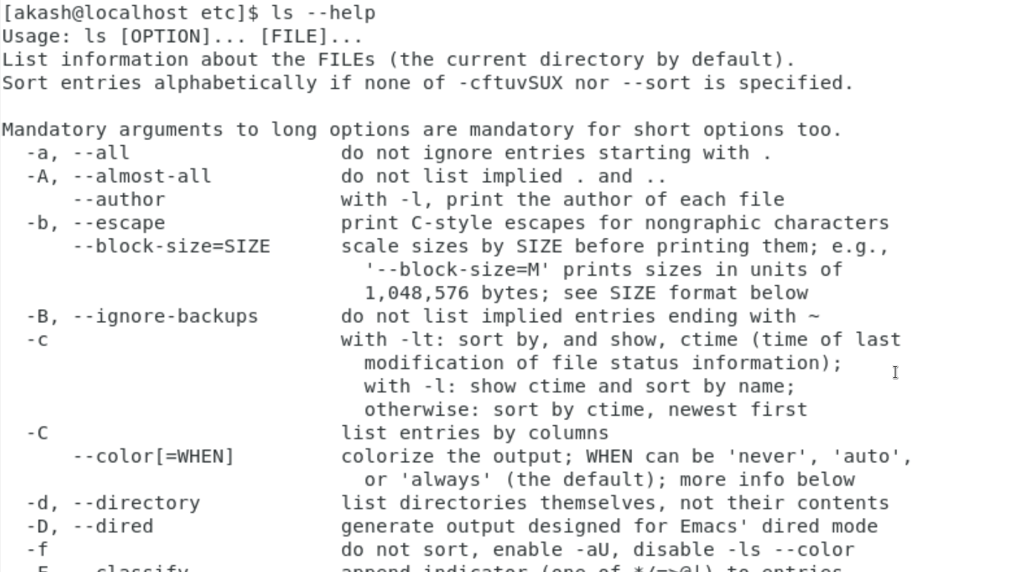

**Ans :**

Lists the total files in the directory and subdirectories, the names of the files in the current directory, their permissions, the number of subdirectories in directories listed, the size of the file, and the date of last modification.

**Assignment-5: Know where you are and where you working**

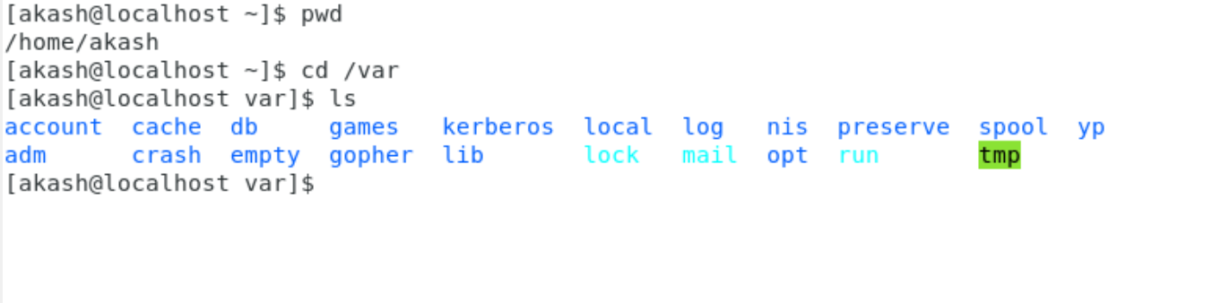

**Ans:**

* The pwd command gives us the path from the home directory to the current location we are in.
* /var contains **variable data files**. This includes spool directories and files, administrative and logging data, and transient and temporary files.

**Saksham Class Assignments**

**Assignment: Update your CentOS Machine**

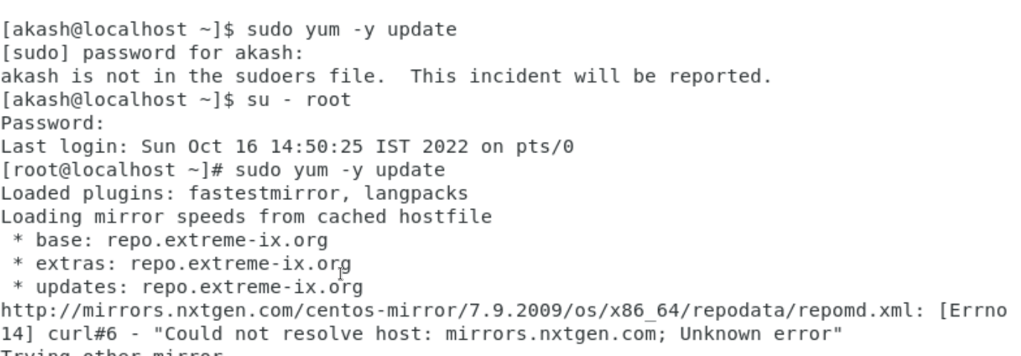

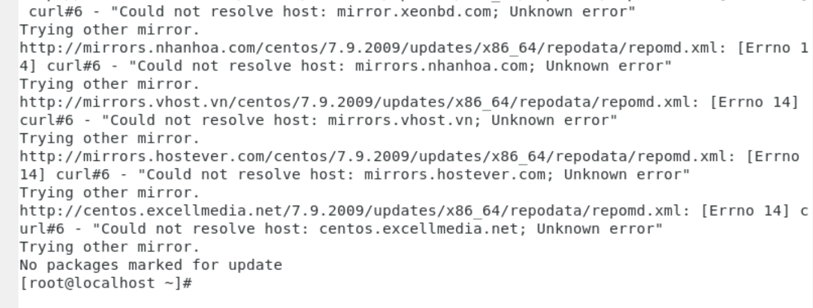

**Ans:**

Updated the CentOS. By logging to root user by the command su - root and then using sudo yum -y update.